HOOD’S FARM - NOVICE SDT
Saturday, August 12 & Sunday, August 13, 2023
Hood’s Farm 610 Wellman Road Ashville, NY

NEBCA sanctioned
ONE trial each class per day * 50 runs each day
Ranch * Pro/Novice * Novice/Novice
Judge: Ron Madison

ENTRIES OPEN – July 1, 2023 Entries received prior, will be treated as opening day entries. Entries close July 12, 2023. Cancellations with full refund will be accepted until the end of the day on July 01. Running Orders will be drawn and posted shortly thereafter.

PRIZES: Ribbons through 10th place. Awards & Payback(Ranch only- if enough entries) dependent on entries..after expenses.

CAMPGROUND - Bear Territory!
Aspen Acres 430 Hoag Road Panama, NY (716) 763 - 1223 Tent & Full Hook ups 3 miles away

HOTELS
Jamestown, NY Holiday Inn Express 2811 N Main St Jamestown, NY (716) 487 – 0001 12 miles away
Falconer, NY – Quality Inn 1980 E Main St Falconer, NY (716)665 – 3670 15 miles away
*** Very Limited Camping available on property. No hookups – self contained only. **** NO WATER availability at the farm.

The Jamestown area on Chautauqua Lake can be pretty booked. It is a resort area. Check for pet policies.

IN CASE OF EMERGENCY - Dial 911 for quickest response. – Local Emergency Room: Both are 10 miles / 20 mins from Hood’s Farm
UPMC Chautauqua Emergency Dept 207 Foote Ave Jamestown, NY 716-664-8120
WellNow Urgent Care 15 S Main St Jamestown, NY 716-489-3144

Local Veterinarian:
Lakeside Veterinary Medicine 976 Fairmount Ave Jamestown, NY 9 miles away
Phone: (716) 708 - 1010

FOOD: Will be ordering from the Ashville General Store for lunches – serves salads, pizza & sandwiches plus convenient store 5 miles. Some restaurants in Sugar Grove, PA, Lakewood NY, & Jamestown, NY.

DIRECTIONS HOOD’S FARM 610 Wellman Road Ashville, NY GPS usually takes you somewhere near a big field or by a house, which is quite a distance from where the sheep barns are. Some gps units take you down Big Tree Rd to Lawson Road and then a right onto Wellman. The barns will be across the street from that Stop Sign on Lawson Rd. If coming down Wellman Rd, in which case the barns will be on your Right – just before Lawson Road.
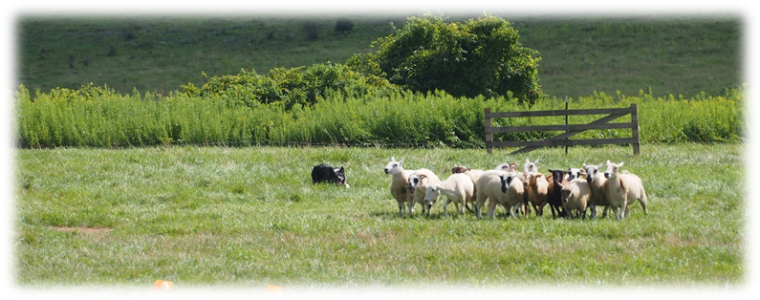

HOOD’S FARM – NOVICE SHEEP DOG TRIAL - ENTRY FORM
August 12 & 13, 2023

HANDLER’S NAME: _____________________________________________________________________

ADDRESS: _____________________________________________________________________________

PHONE: __________________________________ EMAIL: _____________________________________

Are you staying overnight? RV - length _______ or Tent Fri _____ Sat____ Sun _____

Ranch $50 / Pro-Novice $45 / Novice-Novice $40 .. each day

DOG’S NAME RANCH PRO-NOV NOV-NOV FEE

TOTAL: __________________

Volunteers Needed: Set Out Exhaust Sheep Pens Scribe Timer Paperwork Runner Hospitality

Make Checks Payable to Jean Barrett.
Send Entries to Jean Barrett 6783 Belle Heights Road Derby, NY 14047
Questions? Please email Jean at thedogandewe@gmail.com or text/phone (716)270-9718

ALL HANDLER’S MUST SIGN AGREEMENT TO THE FOLLOWING WAIVER:

I assume all risks to self, dog(s), dependents and property while involved in any way with this trial. I agree to hold harmless NEBCA Inc., Hood’s Farm, Courtney Hood, trial managers, trial committee, trial volunteers, judge and any and all others involved in this trial in any way. Furthermore, I agree to pay for any damage to person, animals or property caused by me, my dog(s), or my dependents while involved in this trial. (Sheep are valued at $350/sheep) I understand that the trial managers will enforce safe and mannerly behavior and sportsmanlike conduct throughout the trial. Those in violation will be asked to leave without a refund. Additionally, I fully understand and take full responsibility that attending this event may put me and my family at risk for exposure to COVID-19 and will not hold any party associated with the event responsible in anyway. I will also take as many precautions as required by trial mangers to aid in the preventable spread of COVID-19.

Signature: _______________________________________________________ Date: __________________

